**UserManagementApplication Test Document**

**Save User:**

**Request and response:**

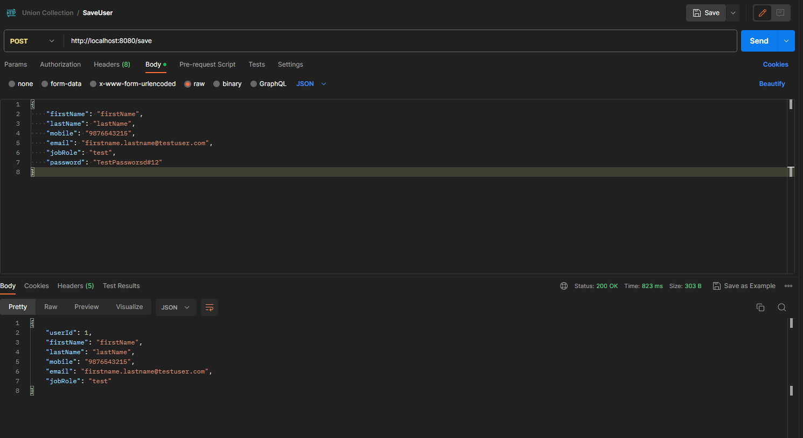

**Update User:**

**Request and response:**

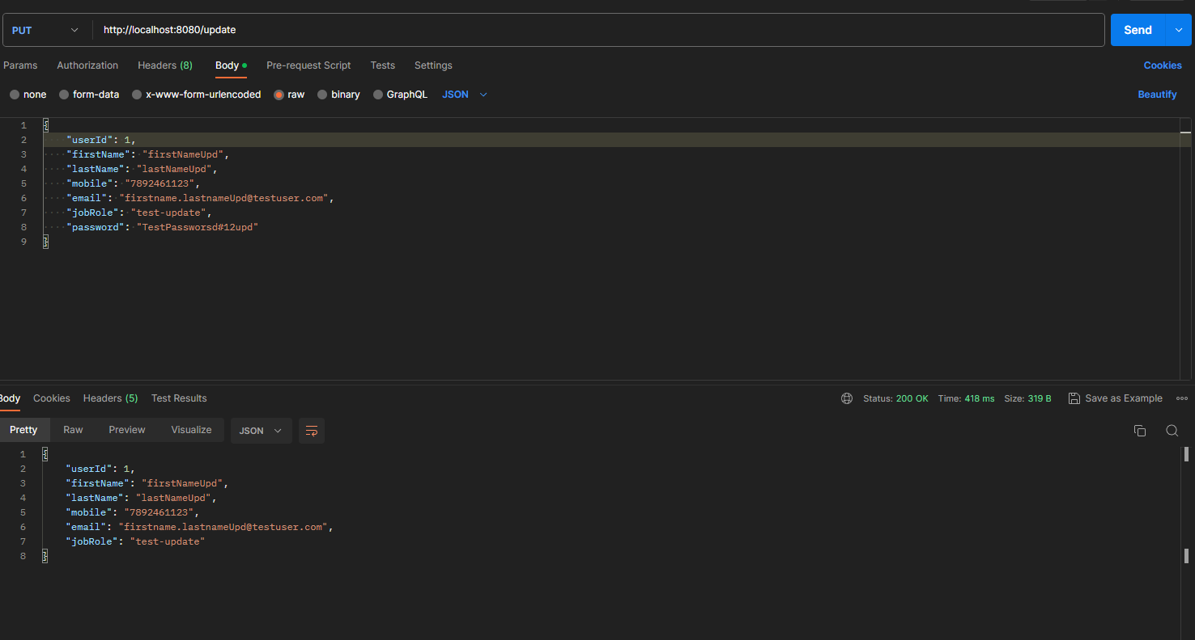

**Get By User Id:**

**Request and Response:**

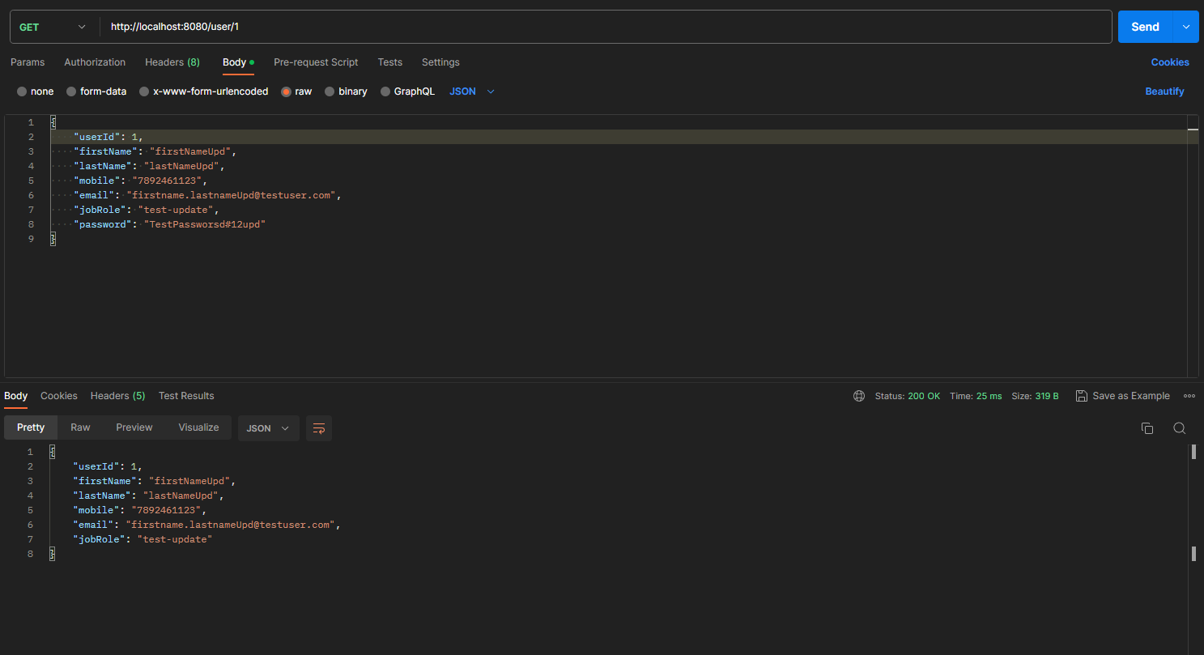

**Delete by user id:**

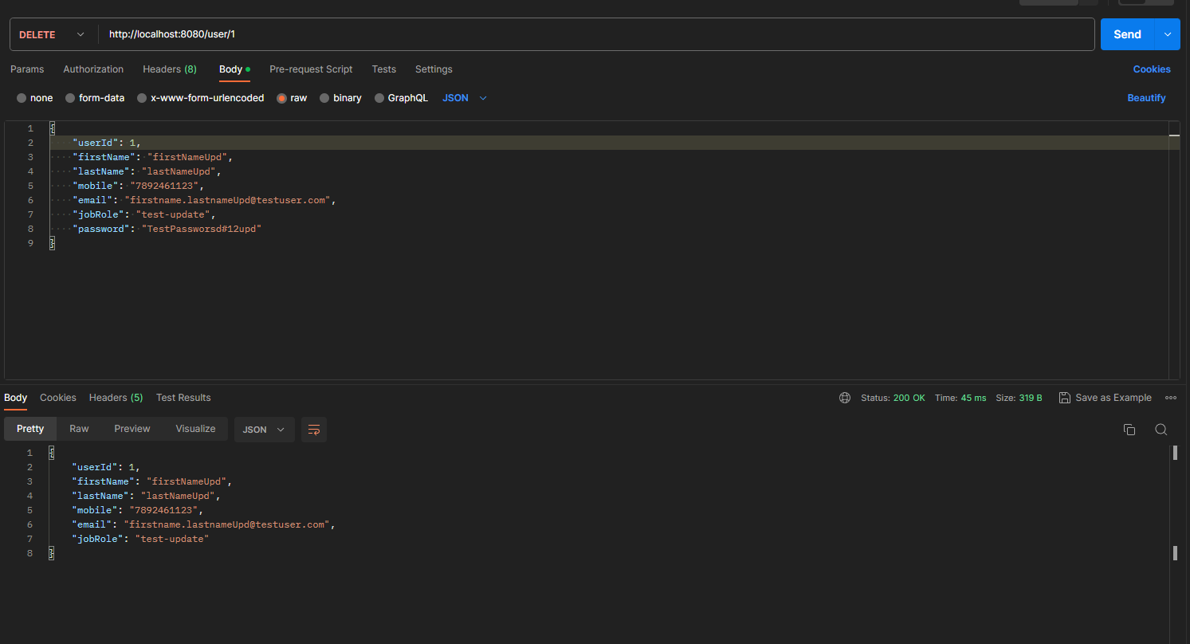

**Field-Error Validation:**

1. **User Id not a positive number**
2. **First name size is more than 50**
3. **Last name size is more than 50**
4. **Mobile number size is more than 10 and also alphanumeric**
5. **Invalid email id format**
6. **Job role size is more than 50**
7. **Password is not alphanumeric with no special characters and uppercase**

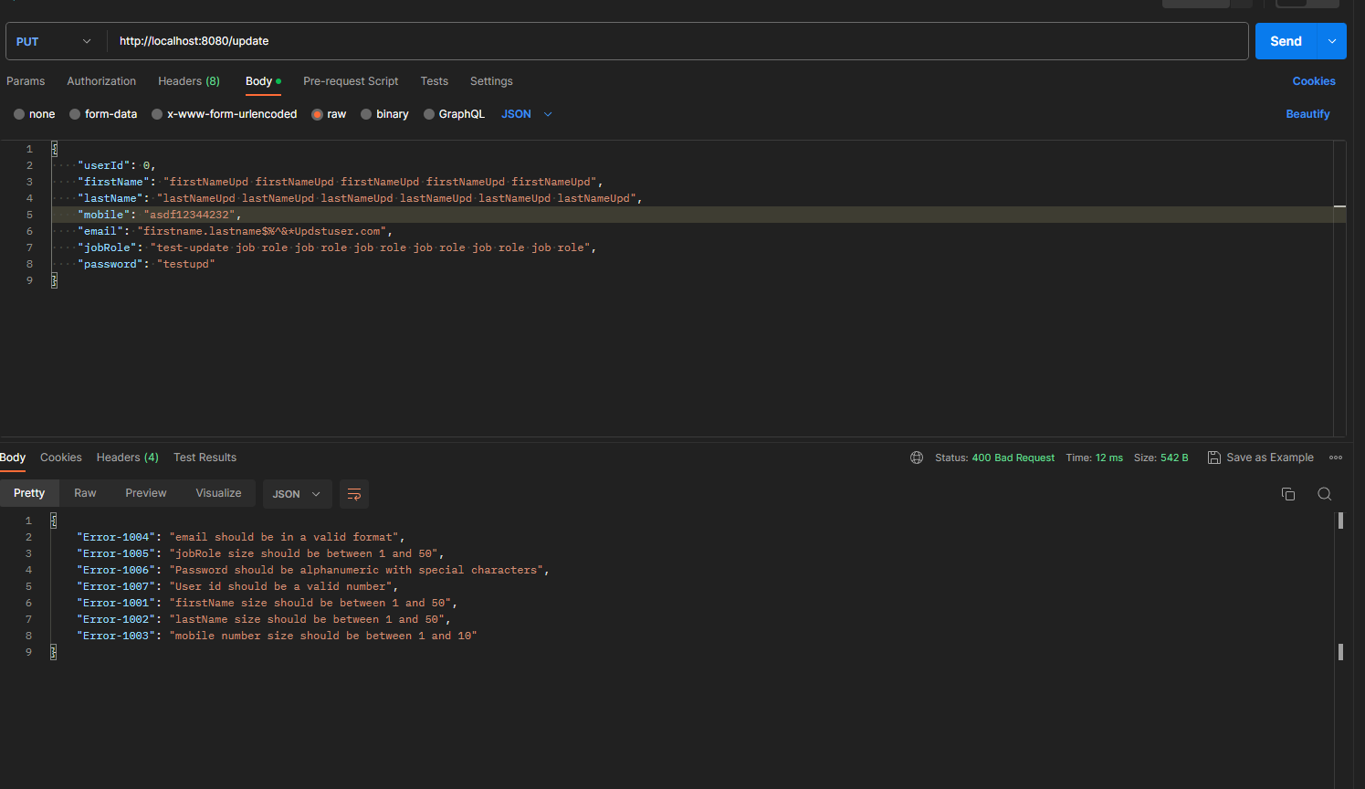

**Database:**

**Table:user**  
  
**Columns:**

|  |  |
| --- | --- |
| **id** | bigint AI PK |
| email | varchar(50) |
| first_name | varchar(50) |
| job_role | varchar(50) |
| last_name | varchar(50) |
| mobile | varchar(10) |
| password | varchar(255) |
| Test data Screenshot |  |

**Password Encryption :**

